INSTRUCTION: Read the following text about Adam.
TOPIC: Frecuency Adverbs

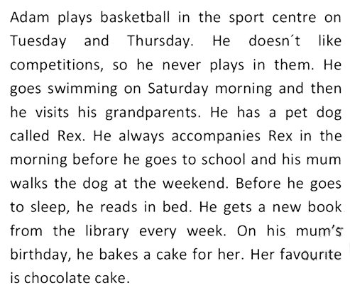

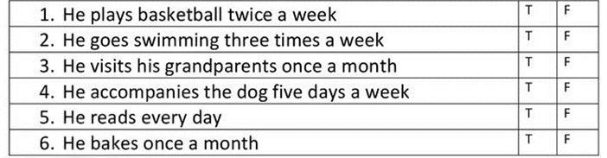
Then, choose true (T) or False (F) according the text.

