READING TOPIC: Weather
INSTRUCTION: Read the two weather experiences of Alexa and Carolina.

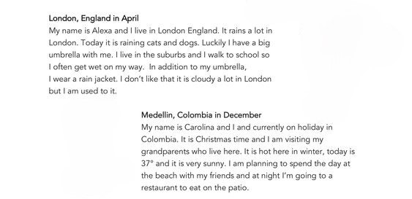
Answer the questions according the texts .
- How hot is it in Medellin today?____________________________
- Who is on holiday?________________________________________
- Where does Alexa live?____________________________________
- Who is going out to eat tonight?_____________________________
- Who has a big umbrella?___________________________________

