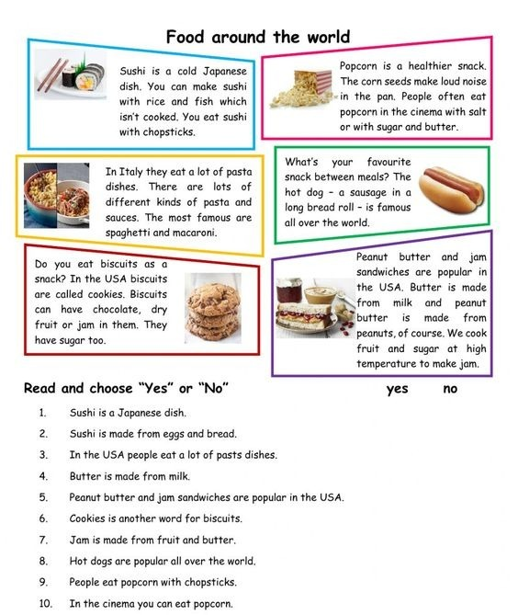
READING TOPIC: Food
INSTRUCTION: Read some short texts about food.

