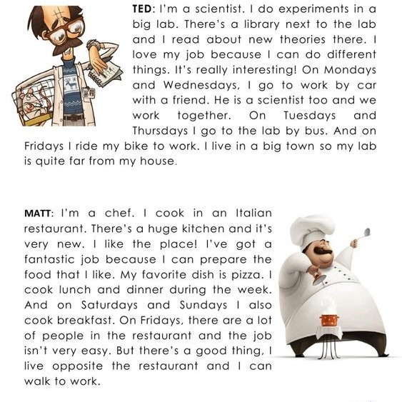
Answer the questions
- What’s the favourite dish of Matt?
- Why does Ted love his job?
- How many people go to his restaurant on friday? According Matt.
- Where does Ted go to do his experiments?
- What store is next to Ted’s lab? What does Ted do there?

READING TOPIC: Jobs, occupations and days of the week.
INSTRUCTION: Read some short texts about Ted and Matt at their job.

