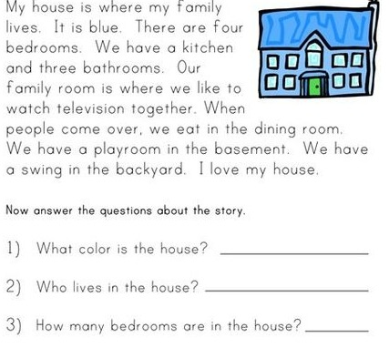
READING TOPIC: House parts
INSTRUCTION: Read the text named “House description”:

