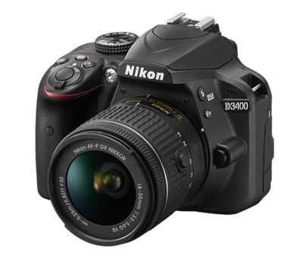

ONLINE TASK

Grammar-Adverbs of frequency

INSTRUCTION: Fill the gaps with those words and phrases.
Picture - to songs - instrument - photos - film - in a tent.

We’ve got some great clubs in my school.
I’m in the Camera Club. It’s brilliant. We usually take (1) ………… in the
school but we also go to the town centre once a month. We sometimes watch (2)………..,too. I joined the Camping Club as well because I’m often
bored at the weekend. About four times a year ,we sleep(3)……………….

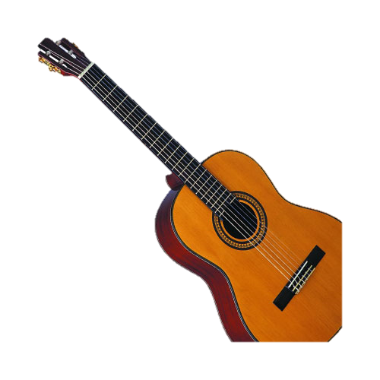
I’m in the Music Club. We always meet twice a week. We listen (4)……………
and we sometimes play an(5) ……………My Friends are in the Art Club and they draw (6)……………..every Monday.

Complete the messages with words and phrases from the box..
always every day sometimes three times a week

1.When we go on holiday ,my mum…………..takes photos of the hotel,but not always.
2.My sister goes to a Music Club on Tuesday,Thursday and Friday .She has a piano lesson………………….
3.We always watch TV after dinner.We watch TV ……………….
4.My best friend wakes up at 7.55 but school starts at eight o’clock so he’s ………………..late.

