READING TIME
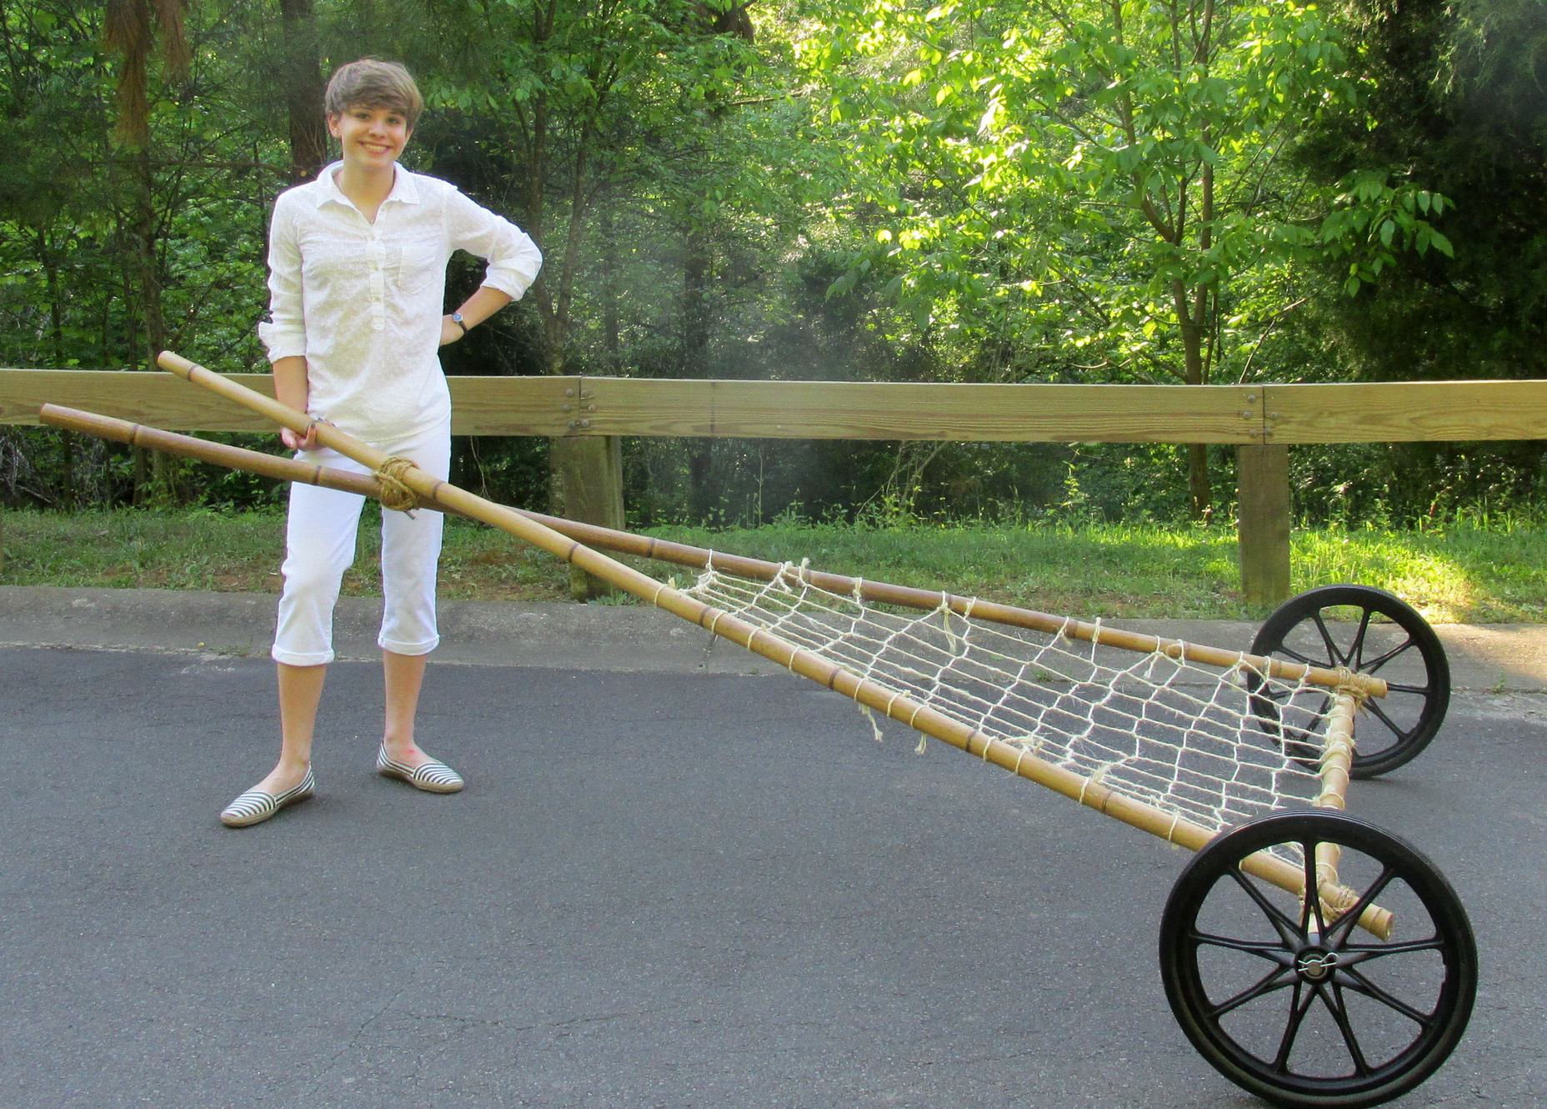
For each question, choose the correct answer.
A new type of transport
Alexis Lewis is a teenager from the USA. She likes to invent - to think of new ideas for things that no one has made before, and then make them.
Alexis often enters competitions for young inventors. When she was younger she spent time with her grandfather, who made transport for people to go to space. One day Alexis' mother told her about a newspaper article which explained how difficult it was to get sick people through the countryside to hospital in Africa. Alexis wanted to help.
Alexis knew that in North America, before there were cars, horses pulled heavy things on a travois (a type of sledge), made of wood. Alexis thought people could do the same, but she added wheels. To make her travois light, she used bamboo, a plant which grows in Africa, not wood.
To pull Alexis' travois, you wear a belt, which means you can carry or hold other things. Alexis thinks her travois might be useful for carrying food home from the market, as well as taking people to hospital. Now it's finished, she's writing instructions for building one so people in Africa can make it themselves.
With help from US companies, Alexis plans to give ten travois free to hospitals in Africa. She doesn't want money for them because they are for poor people.
Alexis doesn't know if she wants to be an inventor when she's older, because she also likes music and writing, but she thinks it's important for children to learn about inventing at school.
1 Why did Alexis decide to invent a new type of transport?
A She wanted to win a competition.
B Her mother told her about a problem.
C Her grandfather worked on spaceships.
2 How is Alexis' travois different from those pulled by horses?
A It is heavier.
B It is made of wood.
It has wheels.

3 What does the writer say about using Alexis' travois?
A People will need instructions to use it.
B People should not use it to carry shopping.
C People can pull it without using their hands.
4 What does the writer say about Alexis' future?
A She might do something different from inventing.
B She would like to teach children how to invent.
C She hopes she can start to sell her inventions.
5 What is the writer doing in this text?
A advertising a new way to travel
B telling the story of someone's idea
C asking for help with a problem

