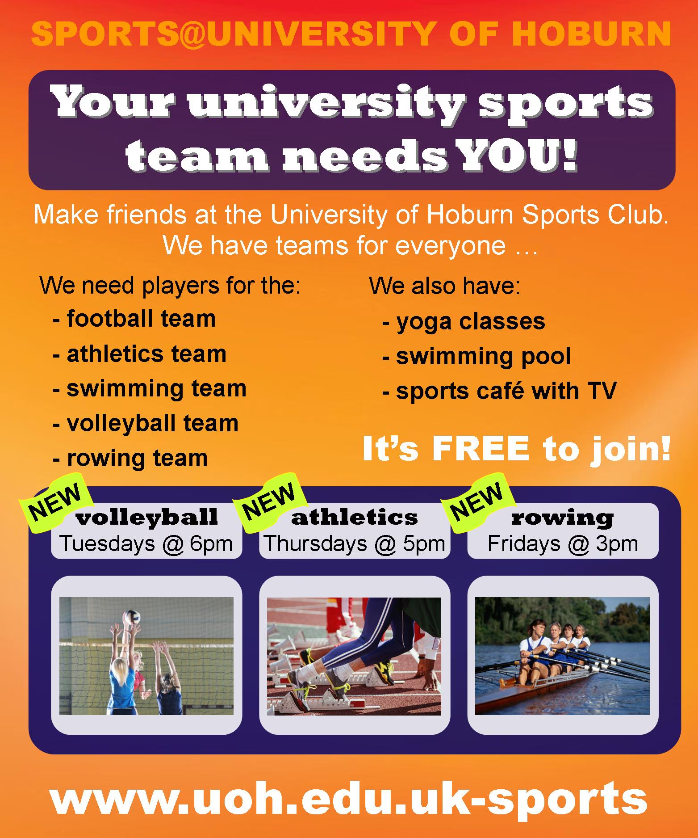
READING TIME

1.-Are the sentences true or false?
There is a TV at the sports café. True/False
The rowing club meets on Saturdays. True/False
The volleyball team meet at 6pm. True/False
The athletics club meets on Tuesdays. True/False
It costs £10 to join. True/False
2 .-Fill the gaps with the correct word from the box.
Thursday - 3 p.m - TV - to join - swimming team - Tuesday
- At the University of Hoburn you can play volleyball on ___.
- At the University of Hoburn you can join the athletics team on ___.
- The rowing club is on Friday at ___.
- The University of Hoburn needs players for the football team, athletics team, volleyball team, rowing team and the ___.
- The University of Hoburn also has a sports café with ___.
- The university sports teams are free ___.

