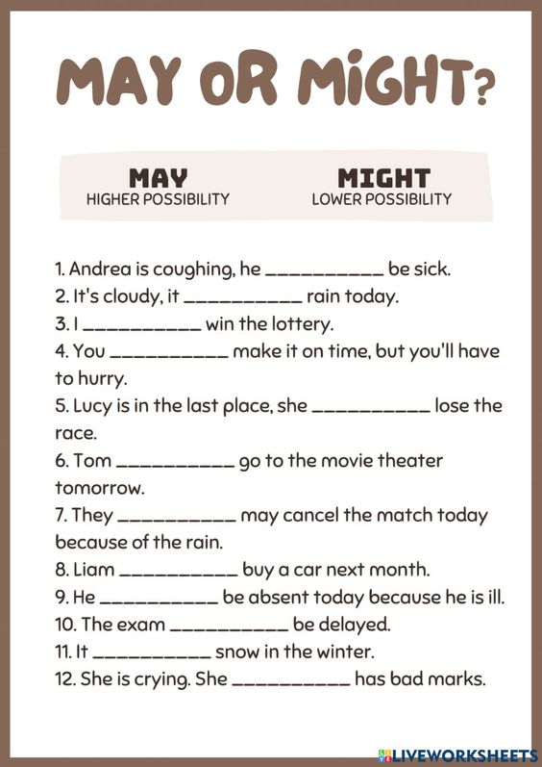
Fill the gaps with MAY and MIGHT.

1. Andrea is coughing, she_______________ be sick.

2. It's cloudy, it _____________ rain today.

3. I _____________ win the lottery.

4. You __________ make it on time, but you'll have to hurry.

5. Lucy is in the last place, she _____________ lose the race.

6. Tom ______________ go to the movie theater tomorrow.

7. They ____________ may cancel the match today because of the rain.

8. Liam ____________ buy a car next month.

9. He _______________ be absent today because he is ill.

10. The exam______________ be delayed.

11.It ______________ snow in the winter.

12. She is crying. She ____________ has bad marks.

