JOBS AND OCCUPATIONS PRACTICE

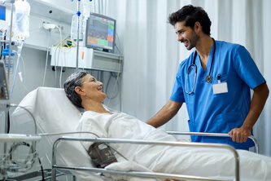
Exercise 1 Complete the sentences with the correct job or occupation.
- A __________ prepares meals in a restaurant.
- A __________takes care of patients in the hospital.
- A __________helps students learn different subjects.
- A __________ investigates crimes and keeps people safe.
- A __________manages financial records and gives advice on taxes.


Exercise 2: Fill in the blanks with the correct verb related to each occupation:
- Doctors __________ sick people.
- Teachers __________ lessons to students.
- Firefighters __________ fires.
- Journalists __________ the news.
- Engineers __________ bridges and buildings.
Exercise 3: Write a short description of your dream job.
_____________________________________________________________________________________________________________________________________________________________________________________________________________________________________________________________________________________________________________________________________________________________________________

KEY ANSWER: Here are the answers for the exercises:

Exercise 1: Fill in the Blanks Exercise 2: Job-Related Verbs
- chef 1. treat
- nurse 2. teach
- teacher 3. put out
- police officer 4. report
- accountant 5. design

